Sprint 2 – UML Diagrams
Recruitment & Hiring Tracker – Altrium (Private) Limited
Prepared by: Vidusha Athukoralage (CB-015652)
Role: Business Analyst – Sprint 2
Module: COMP50074 Professional Practice and Project Management
Live system: https://altrium-recruitment.vercel.app/
Contents

Right-click the contents and choose "Update Field" in Word to show page numbers.

1. Sprint 2 Overview

Sprint 2 Goal
Complete the post-shortlisting workflow over four weeks: schedule interviews around interviewer availability, capture structured evaluations, compare candidates, finalize hiring decisions with automatic emails, and assist candidates through a career chatbot.

Sprint 2 Backlog
ID | Backlog Item
PB06 | Interview & Recruitment Stage Management
PB07 | Interview Feedback & Candidate Evaluation
PB08 | Candidate Progress Tracking & Comparison
PB09 | Offer & Hiring Management
PB10 | Recruitment Assistance & Management Insights

Diagrams in this document
For each of the five Sprint 2 backlog items, this document contains a use case diagram (actors and system functions), an activity diagram (workflow across the user interface, backend and database) and a sequence diagram (message flow between components over time) – 15 diagrams in total.

2. Use Case Diagrams – Sprint 2

PB06 – Interview & Recruitment Stage Management
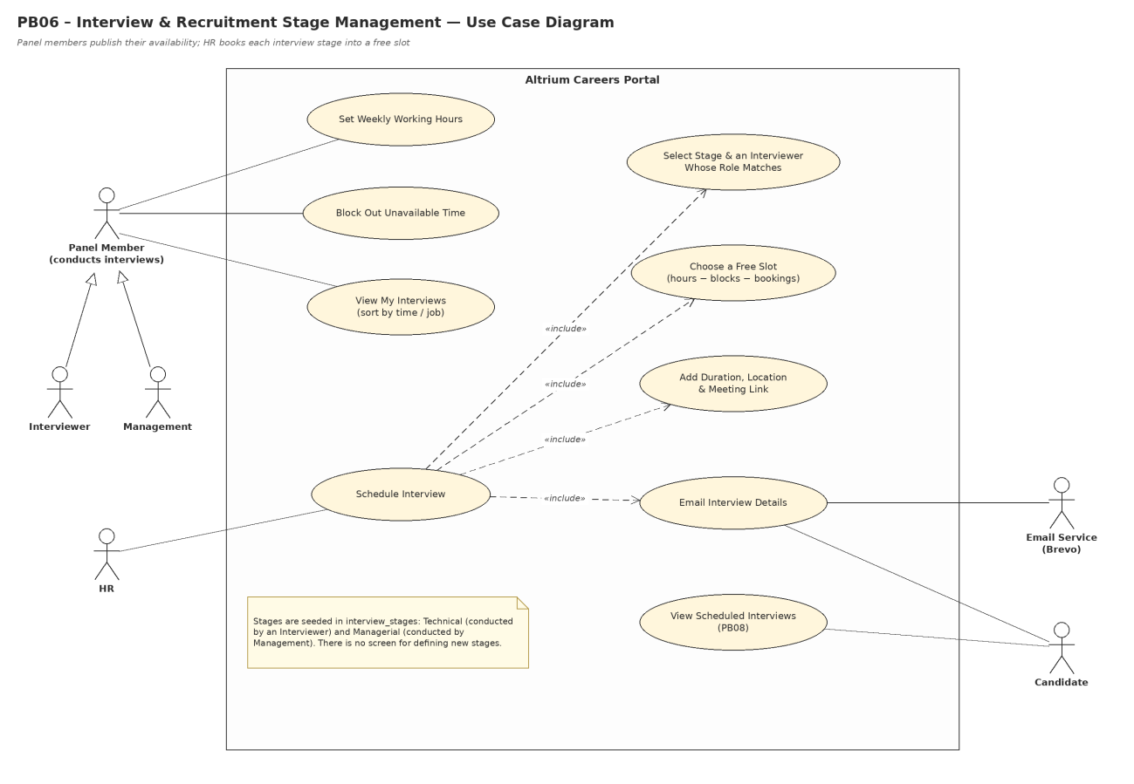
Figure 1 – Use Case Diagram – PB06 Interview & Recruitment Stage Management

PB07 – Interview Feedback & Candidate Evaluation
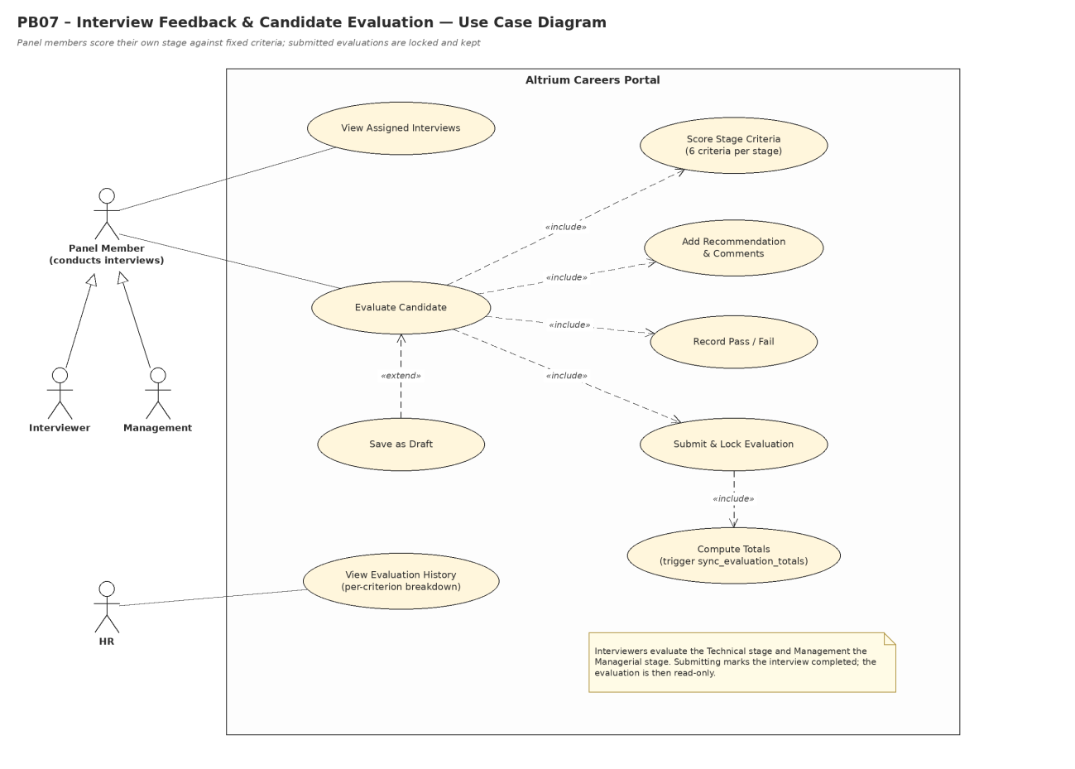
Figure 2 – Use Case Diagram – PB07 Interview Feedback & Candidate Evaluation

PB08 – Candidate Progress Tracking & Comparison
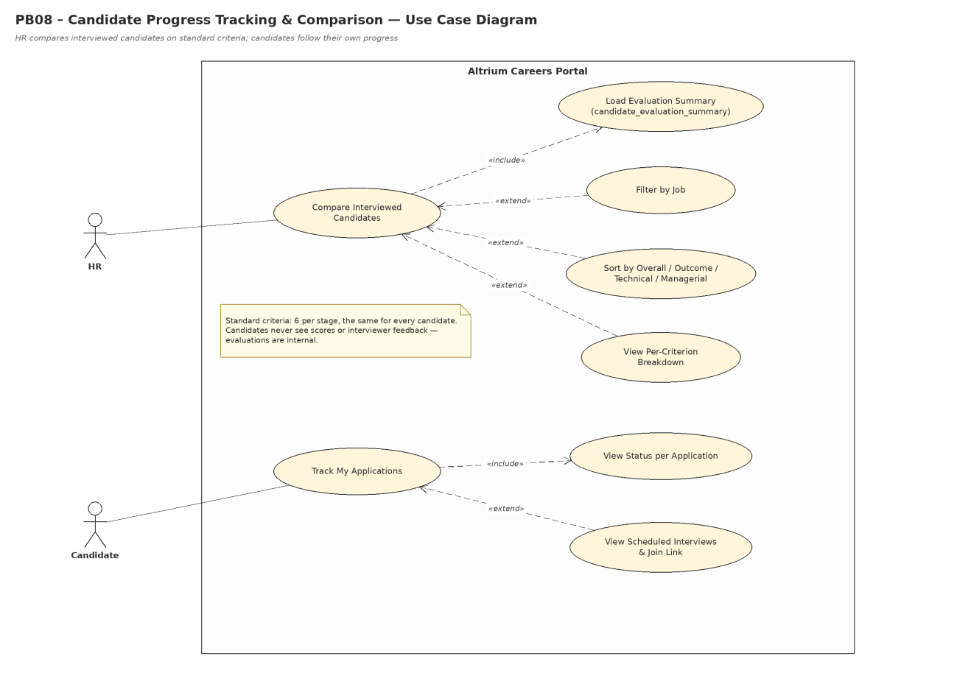
Figure 3 – Use Case Diagram – PB08 Candidate Progress Tracking & Comparison

PB09 – Offer & Hiring Management
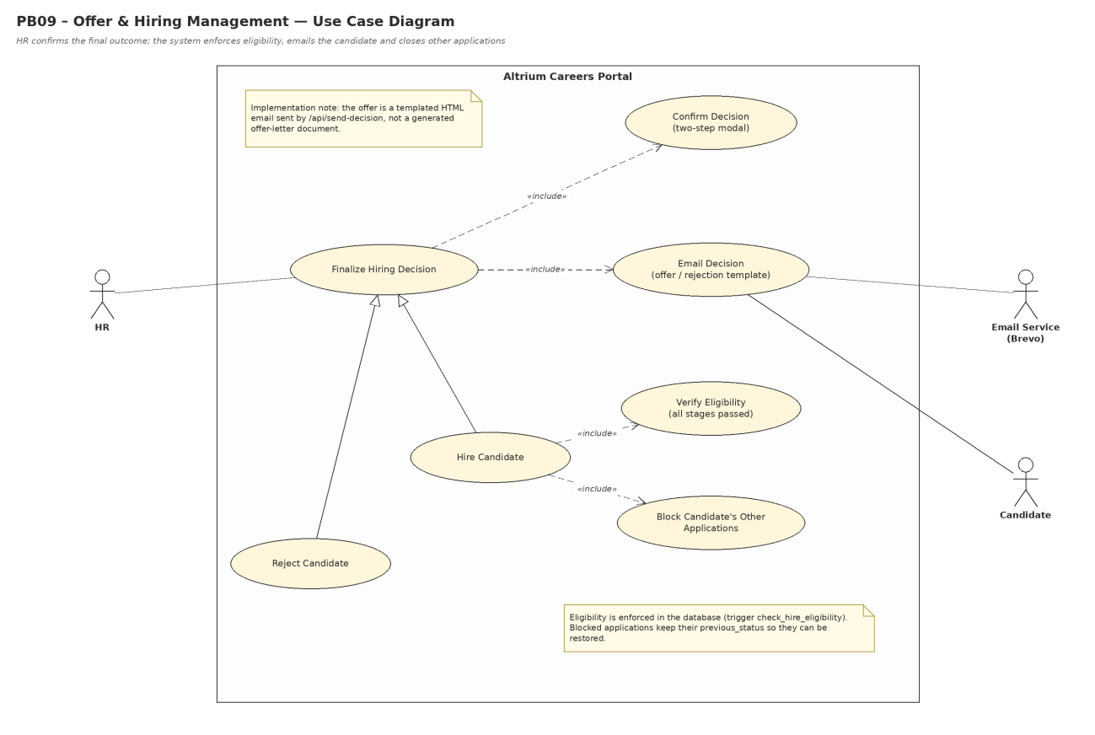
Figure 4 – Use Case Diagram – PB09 Offer & Hiring Management

PB10 – Recruitment Assistance & Management Insights
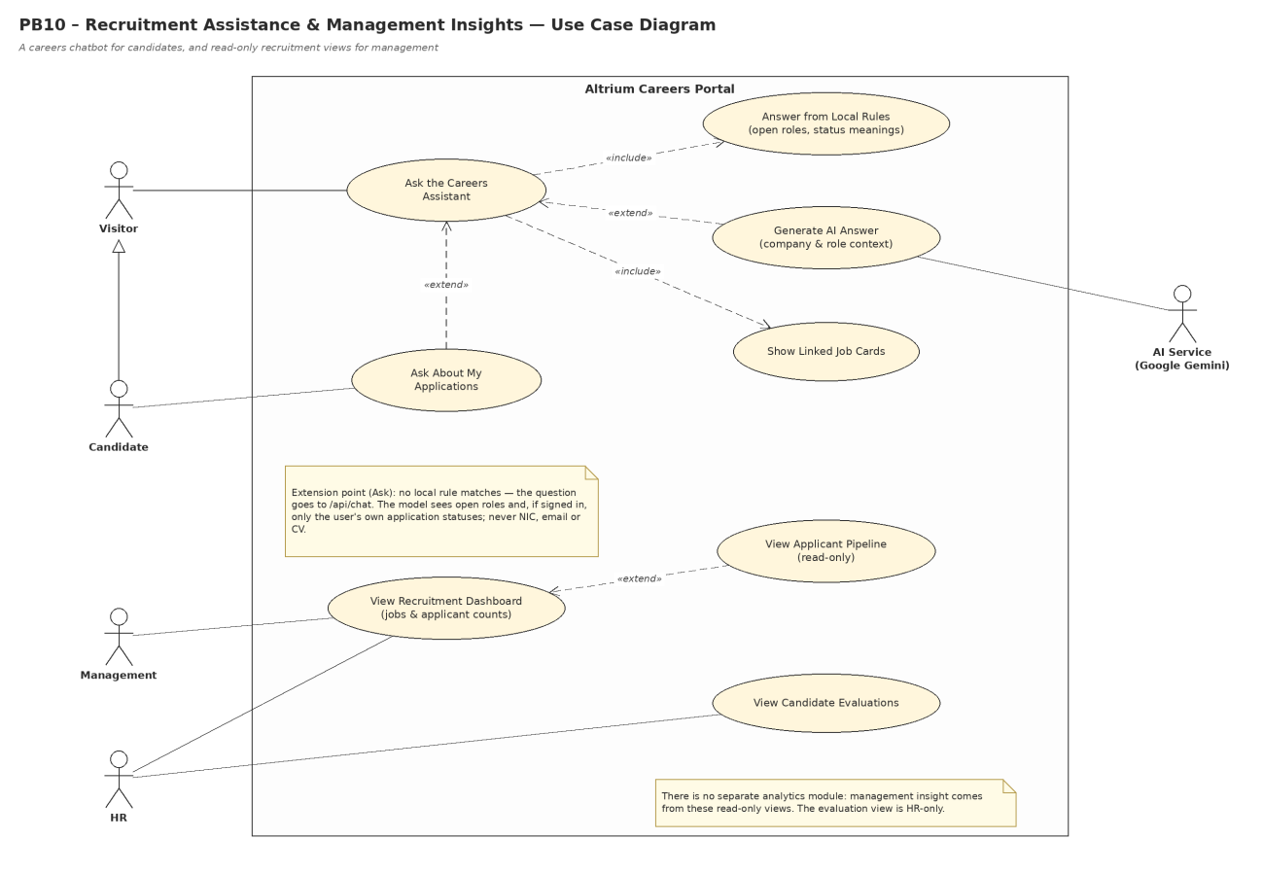
Figure 5 – Use Case Diagram – PB10 Recruitment Assistance & Management Insights

3. Activity Diagrams – Sprint 2

PB06 – Interview & Recruitment Stage Management
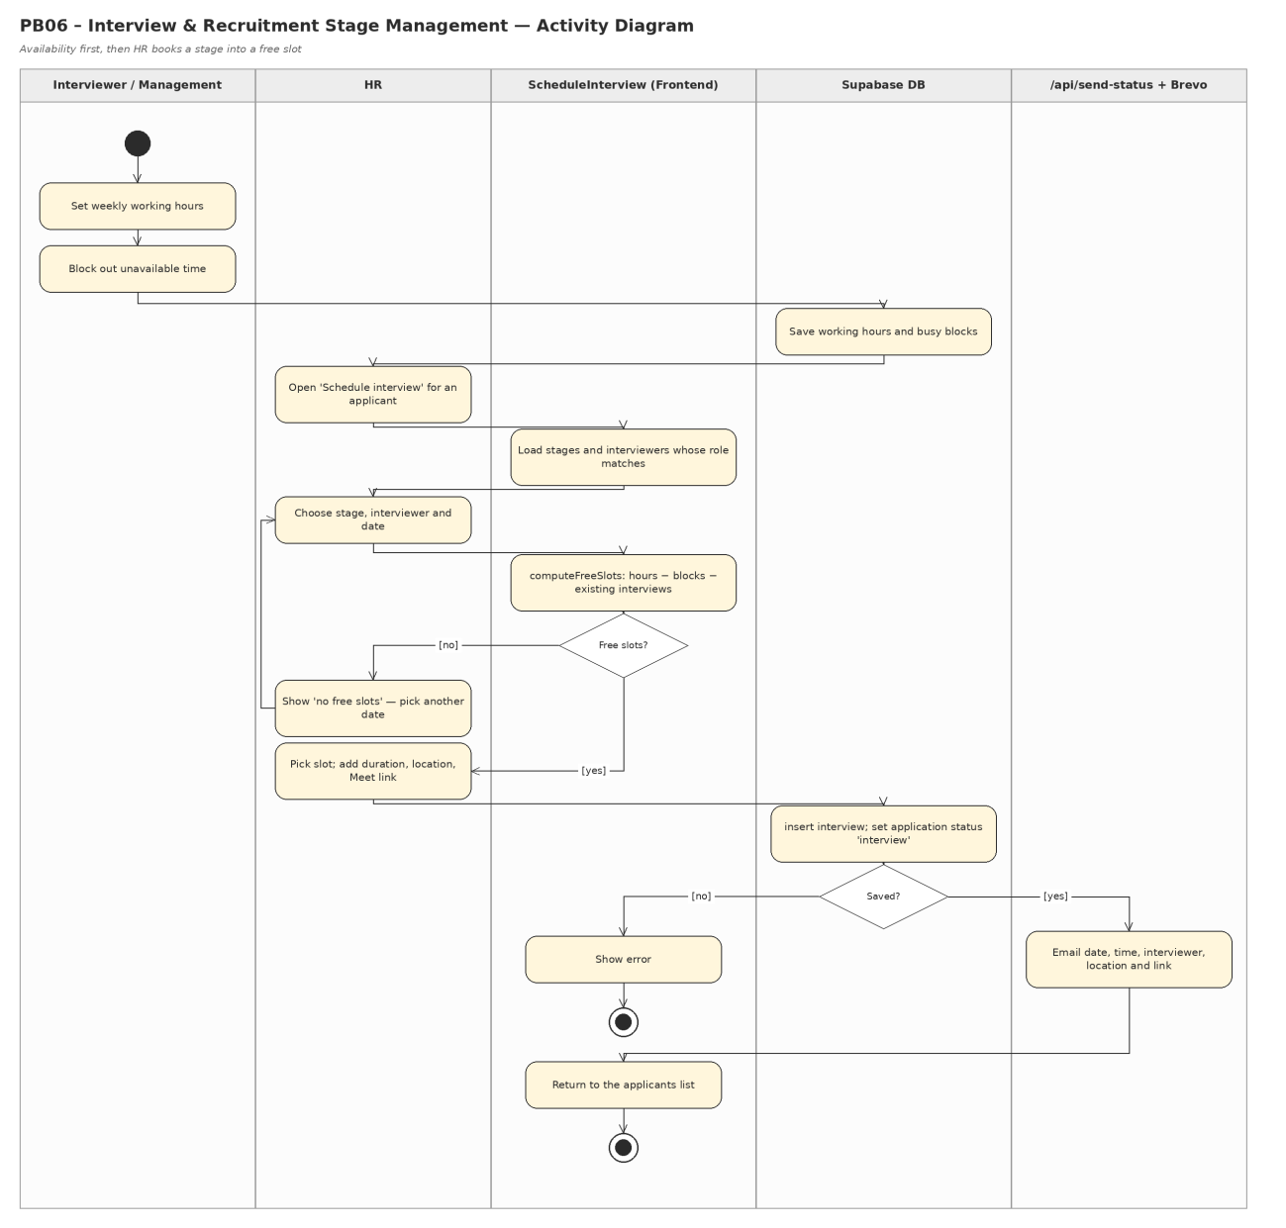
Figure 6 – Activity Diagram – PB06 Interview & Recruitment Stage Management

PB07 – Interview Feedback & Candidate Evaluation
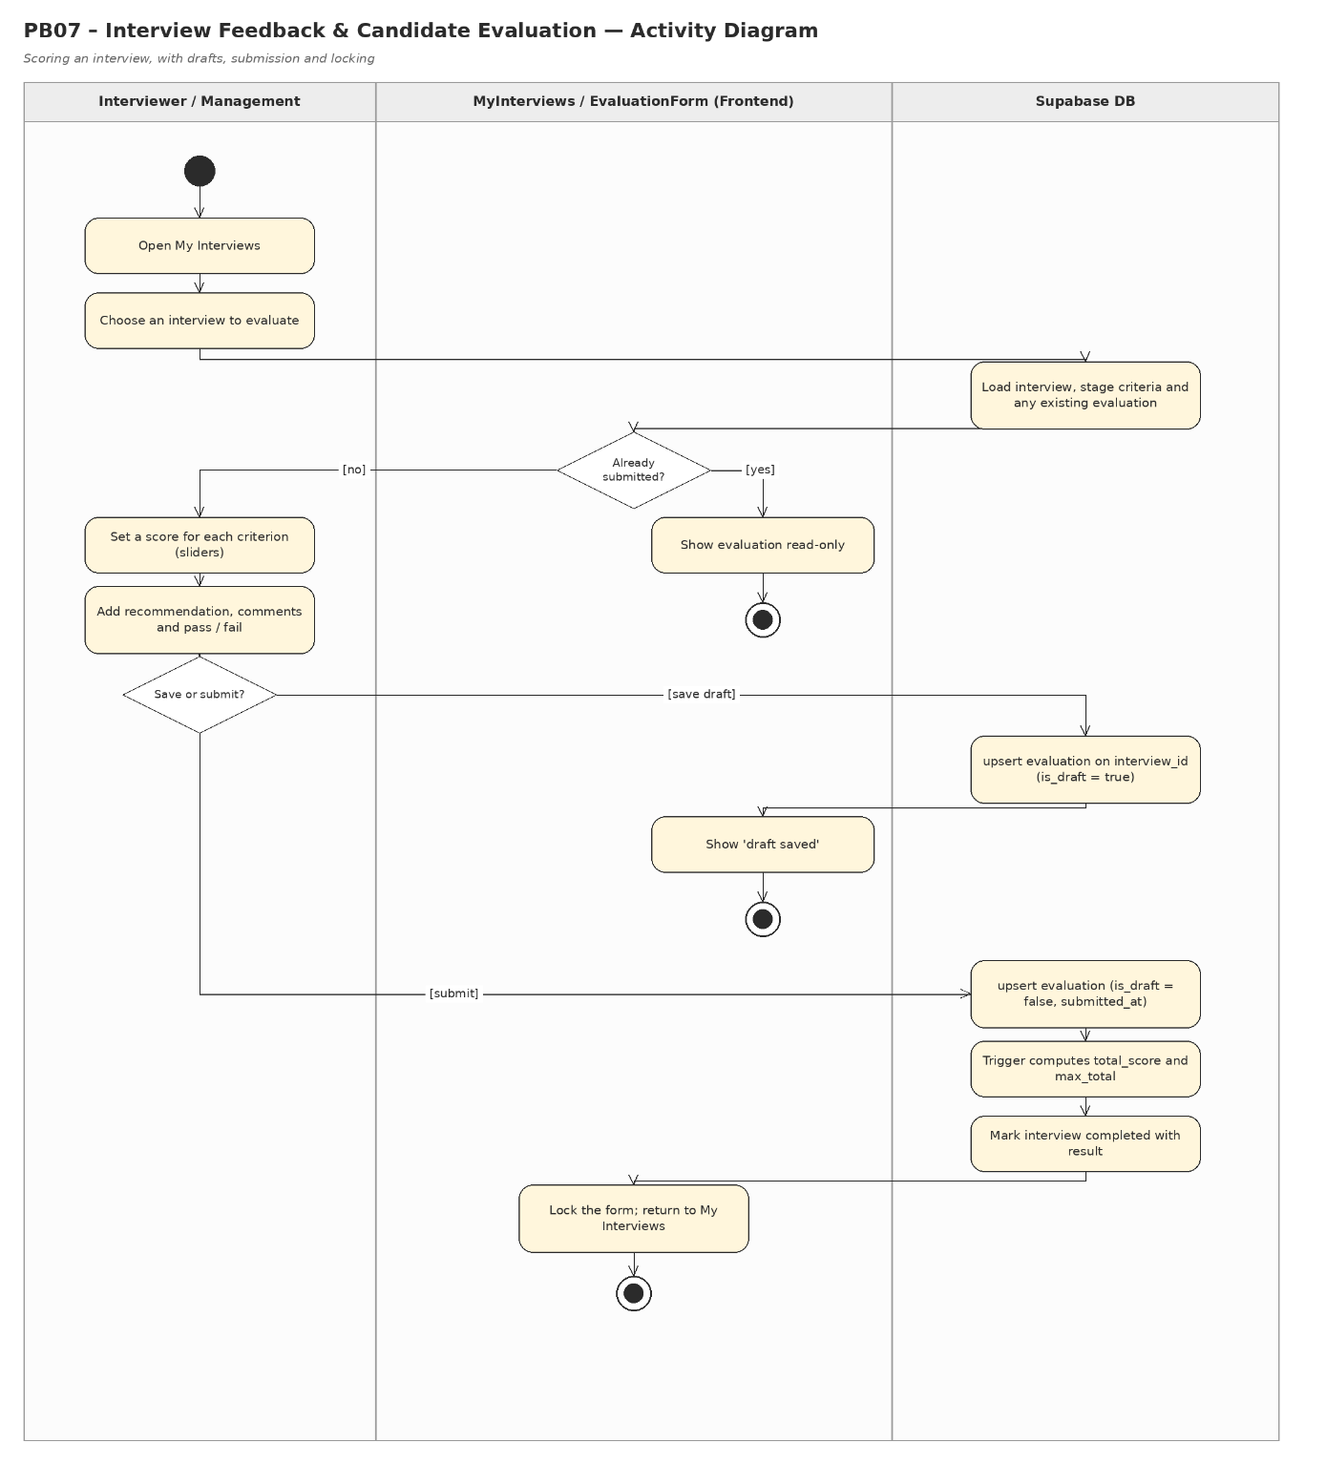
Figure 7 – Activity Diagram – PB07 Interview Feedback & Candidate Evaluation

PB08 – Candidate Progress Tracking & Comparison
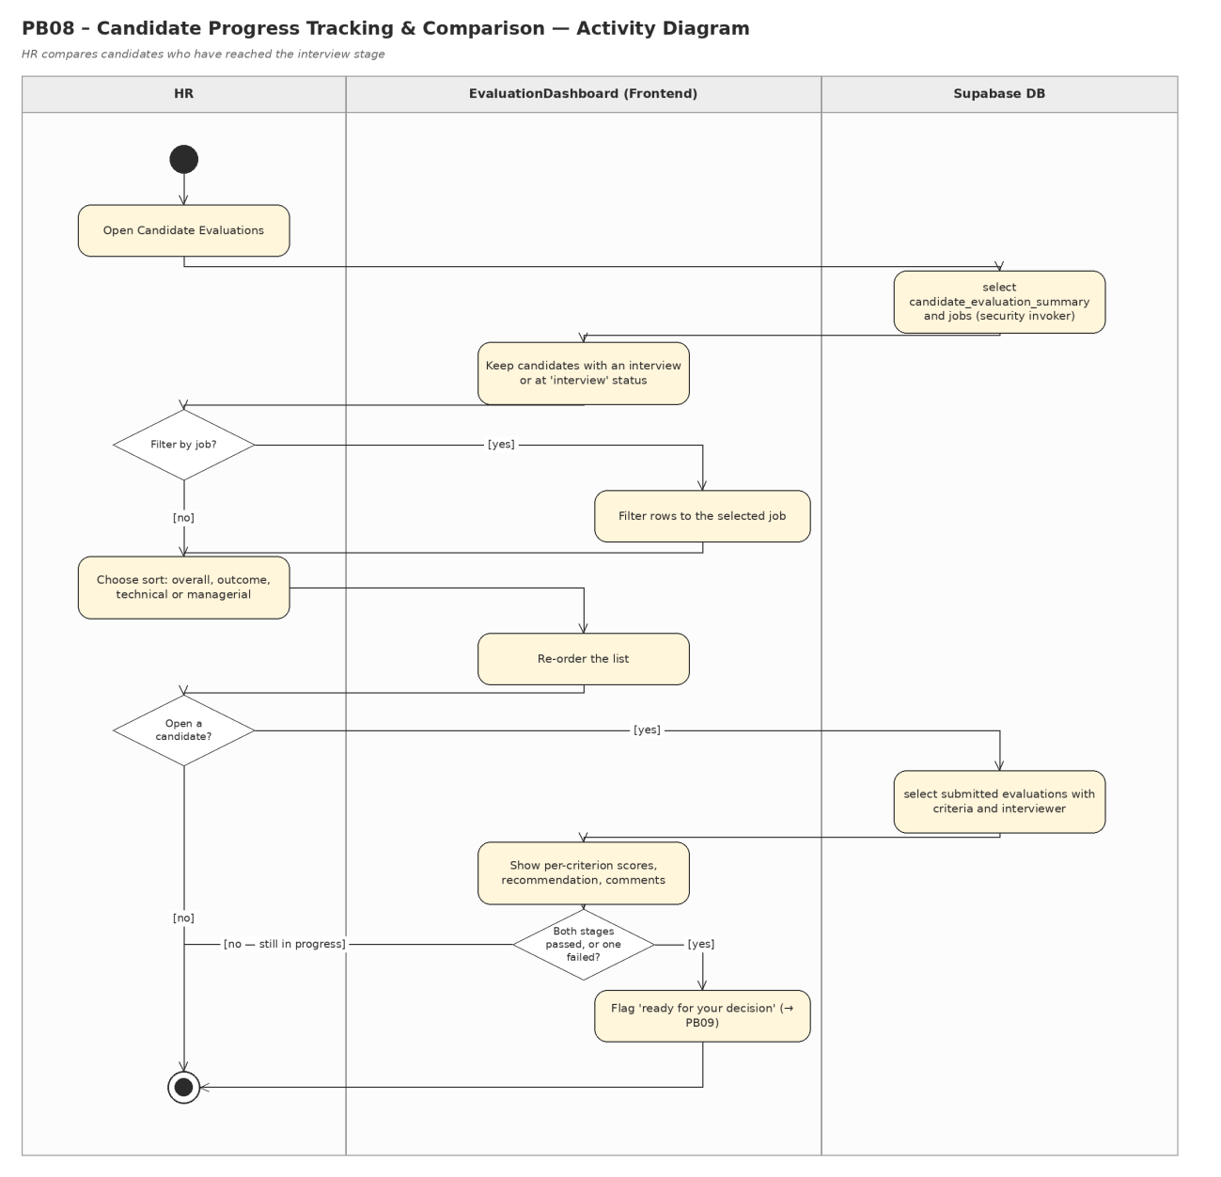
Figure 8 – Activity Diagram – PB08 Candidate Progress Tracking & Comparison

PB09 – Offer & Hiring Management
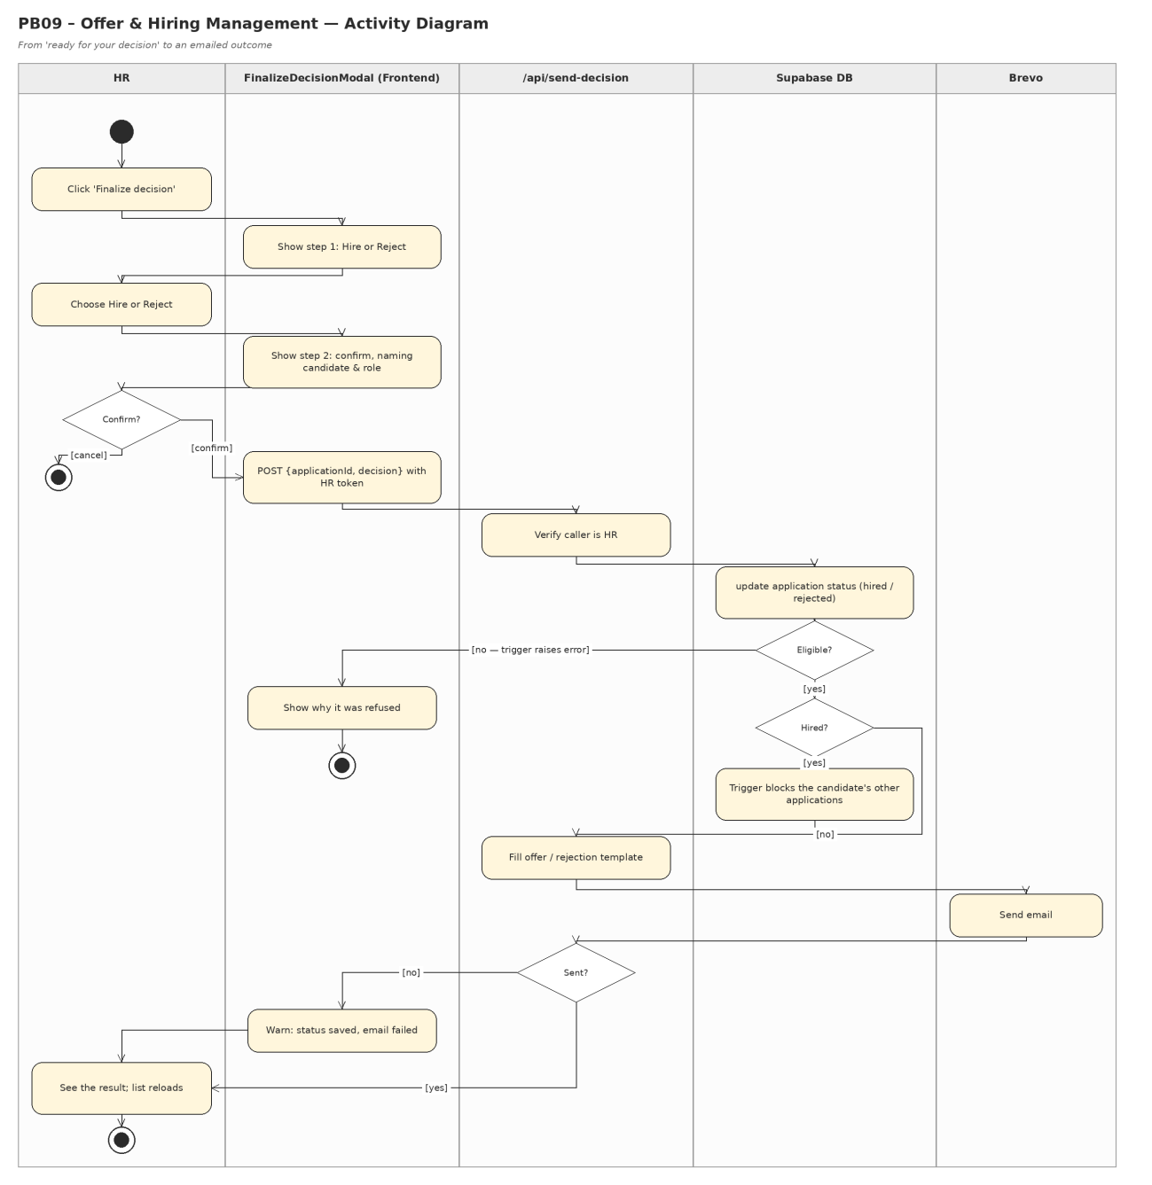
Figure 9 – Activity Diagram – PB09 Offer & Hiring Management

PB10 – Recruitment Assistance & Management Insights
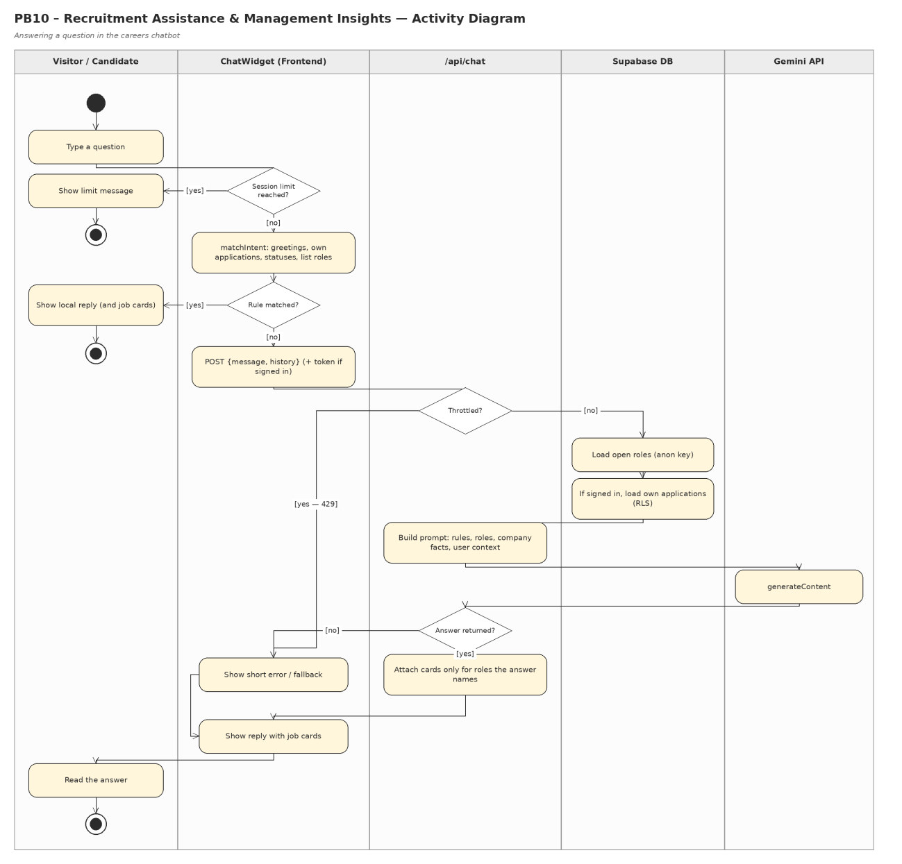
Figure 10 – Activity Diagram – PB10 Recruitment Assistance & Management Insights

4. Sequence Diagrams – Sprint 2

PB06 – Interview & Recruitment Stage Management
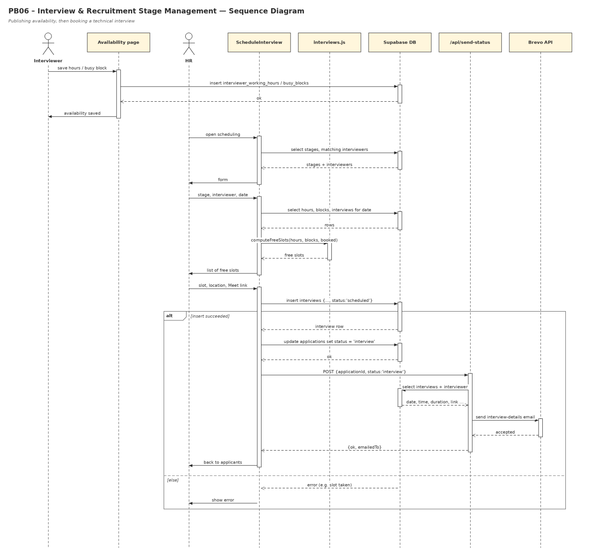
Figure 11 – Sequence Diagram – PB06 Interview & Recruitment Stage Management

PB07 – Interview Feedback & Candidate Evaluation
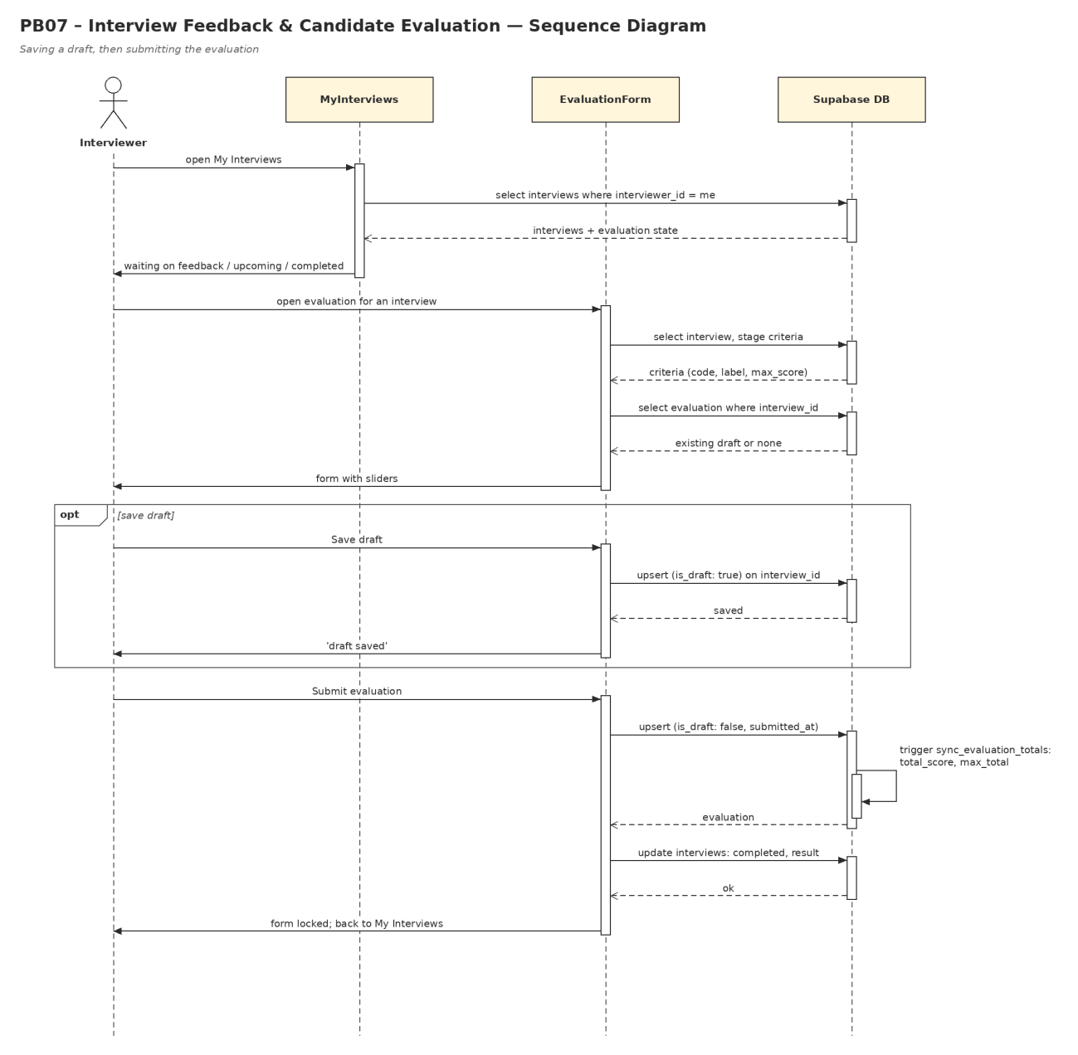
Figure 12 – Sequence Diagram – PB07 Interview Feedback & Candidate Evaluation

PB08 – Candidate Progress Tracking & Comparison
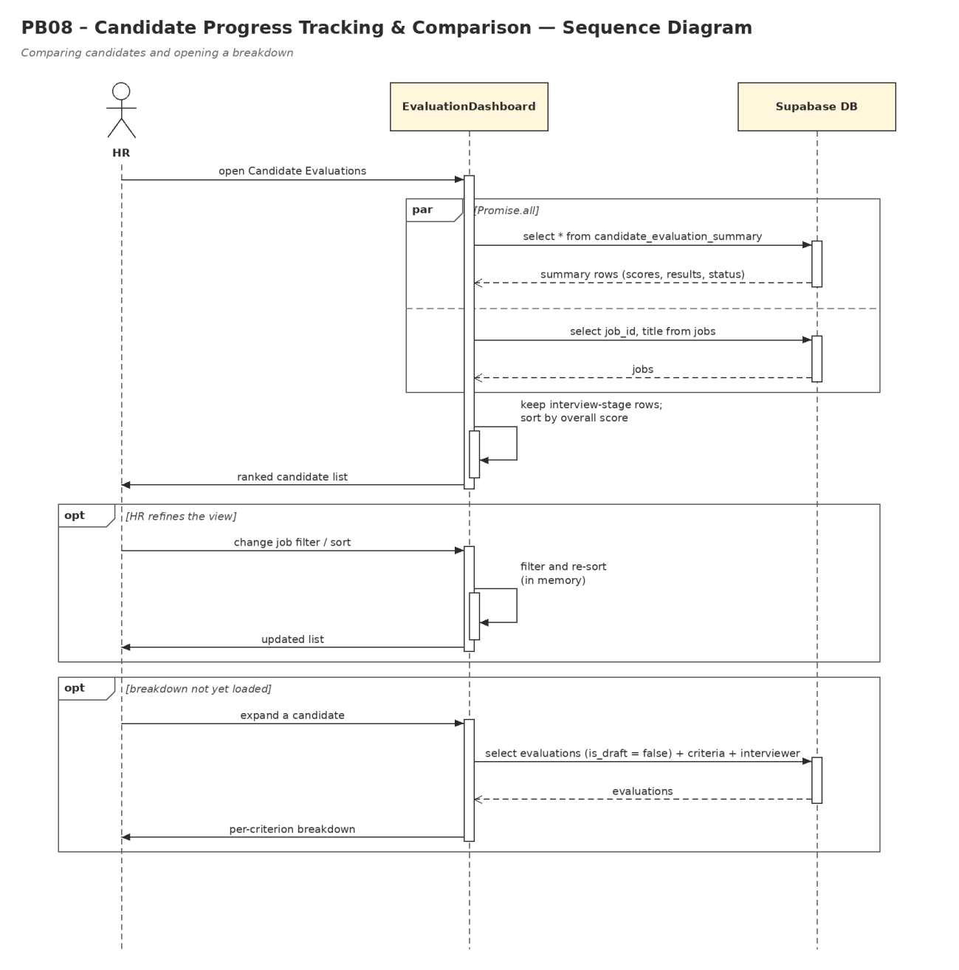
Figure 13 – Sequence Diagram – PB08 Candidate Progress Tracking & Comparison

PB09 – Offer & Hiring Management
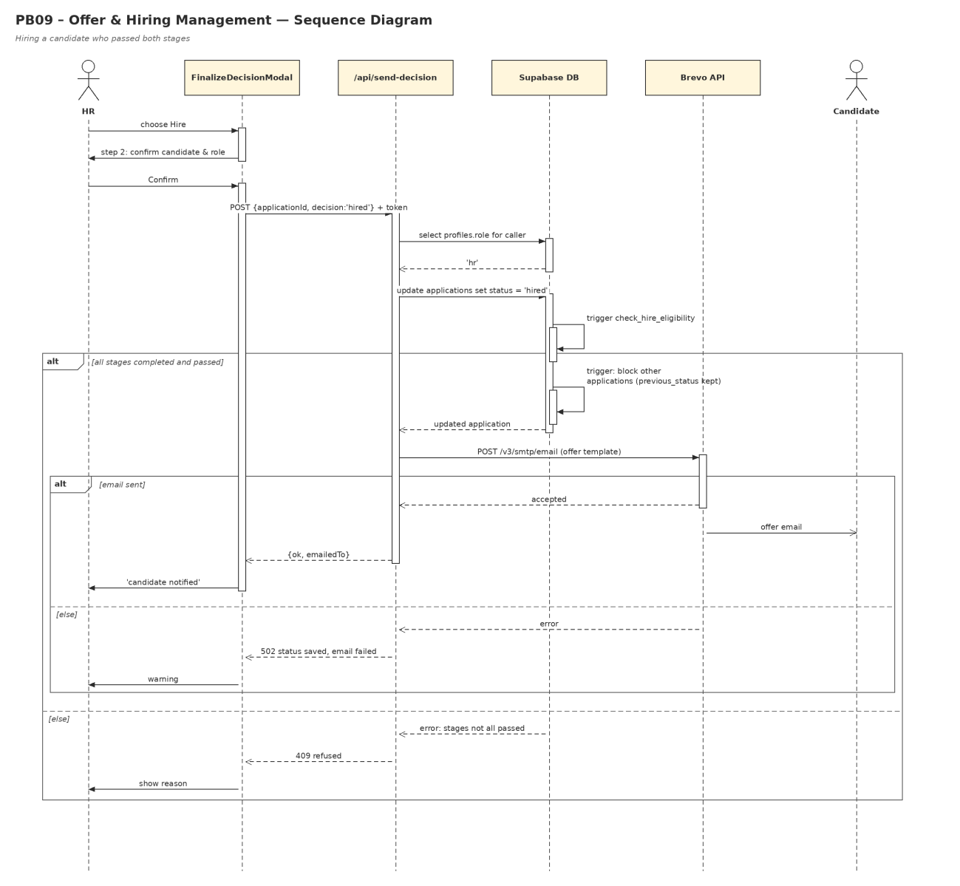
Figure 14 – Sequence Diagram – PB09 Offer & Hiring Management

PB10 – Recruitment Assistance & Management Insights
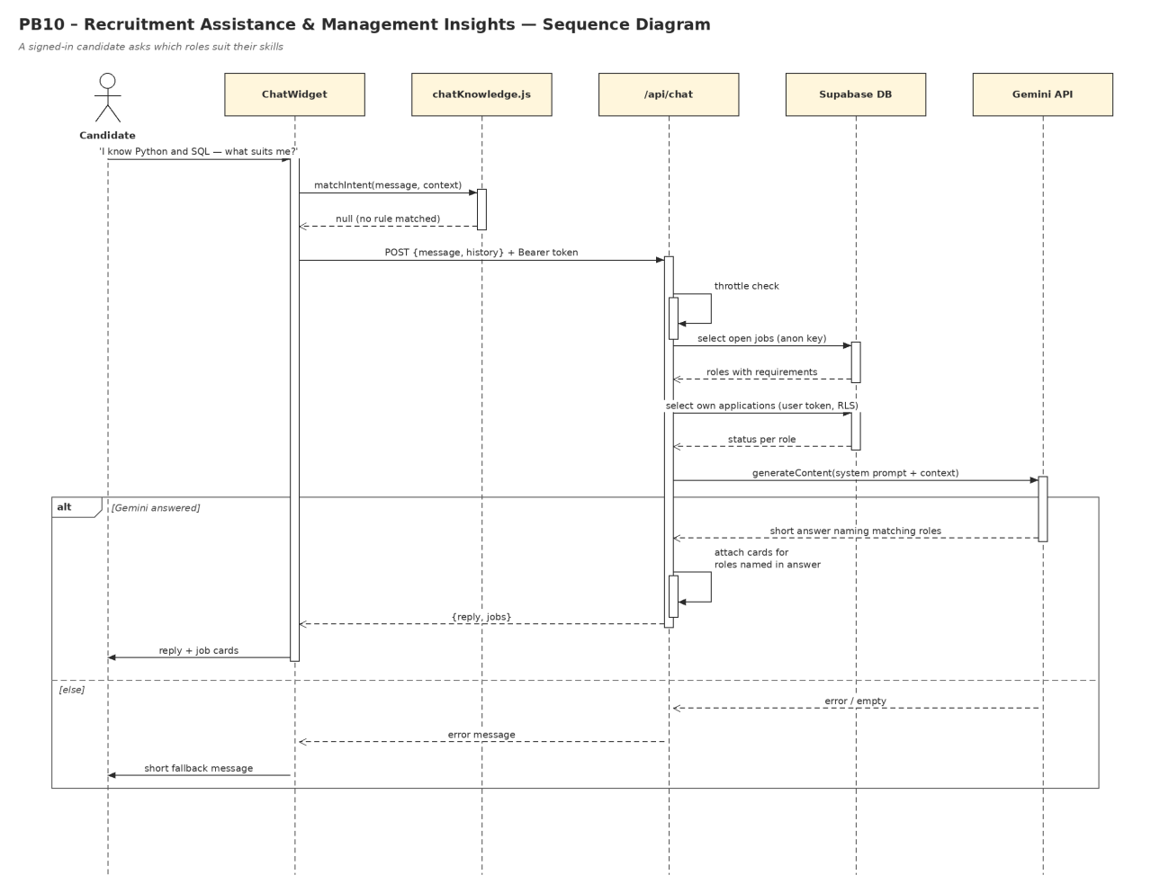
Figure 15 – Sequence Diagram – PB10 Recruitment Assistance & Management Insights

